Linux Directory Structure

1.PWD

mkdir soundarya-directory is created.

Ls : list the files in pwd

Ls -a: list the hiden files.

Ls –l :list the file with properties.

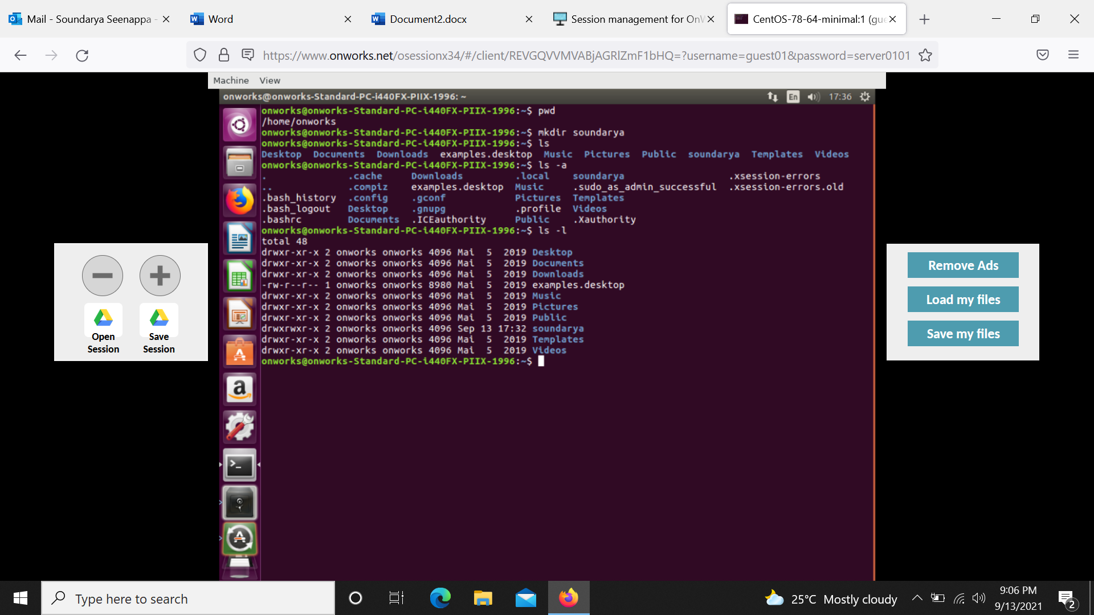

2.Creating files in directory and deleting the files.

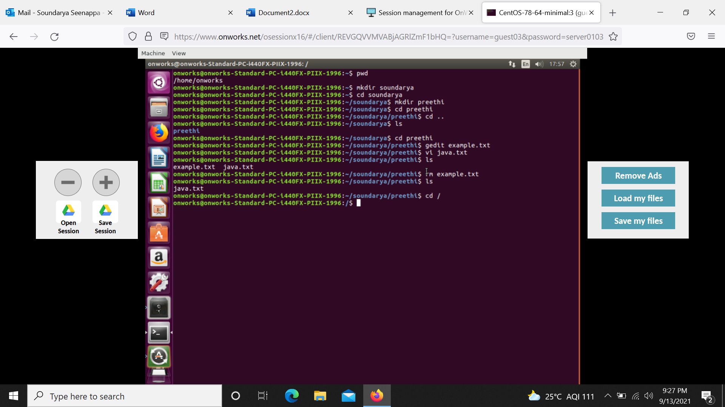

-gedit example.txt

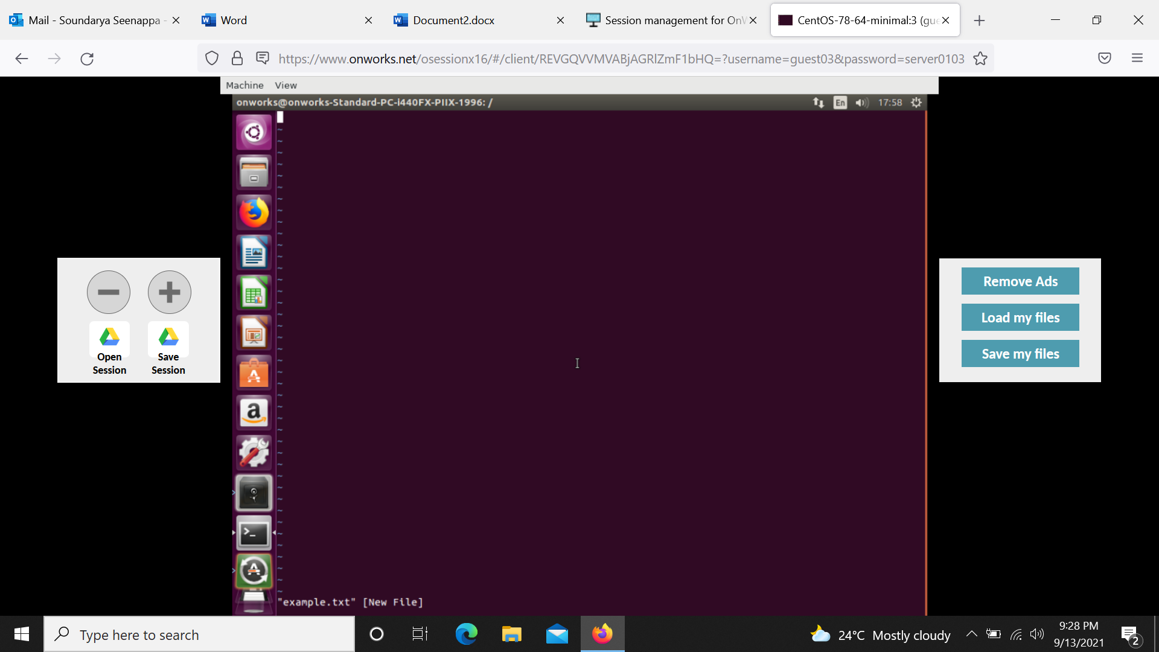

-click Esc,enter :wq

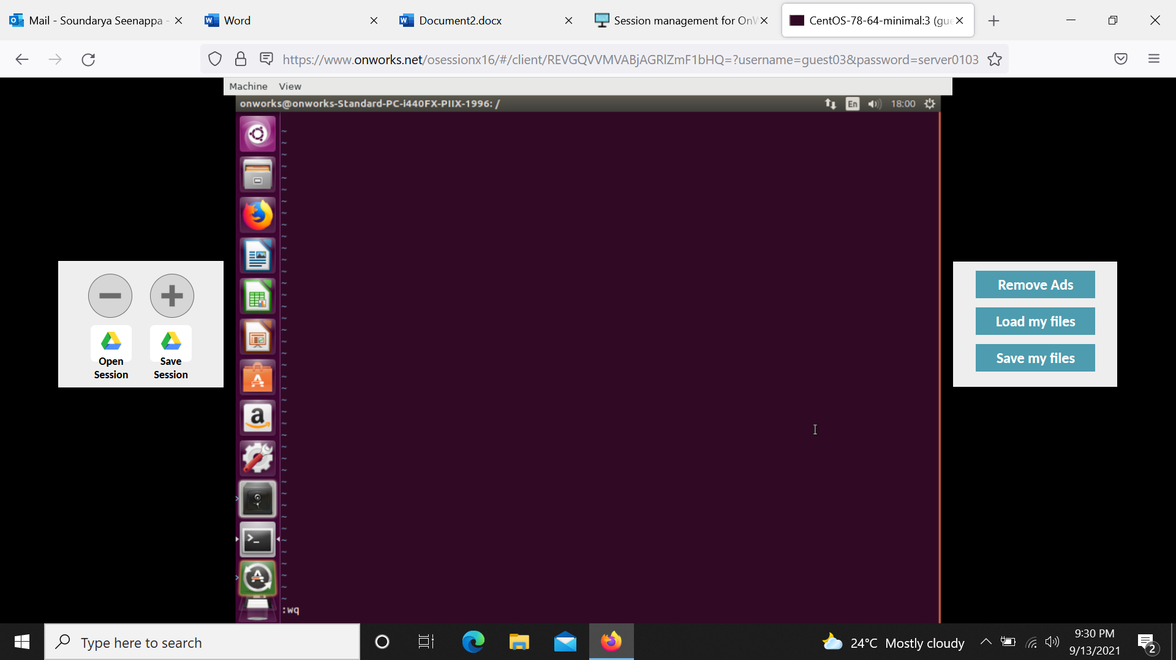

-rmdir example.txt

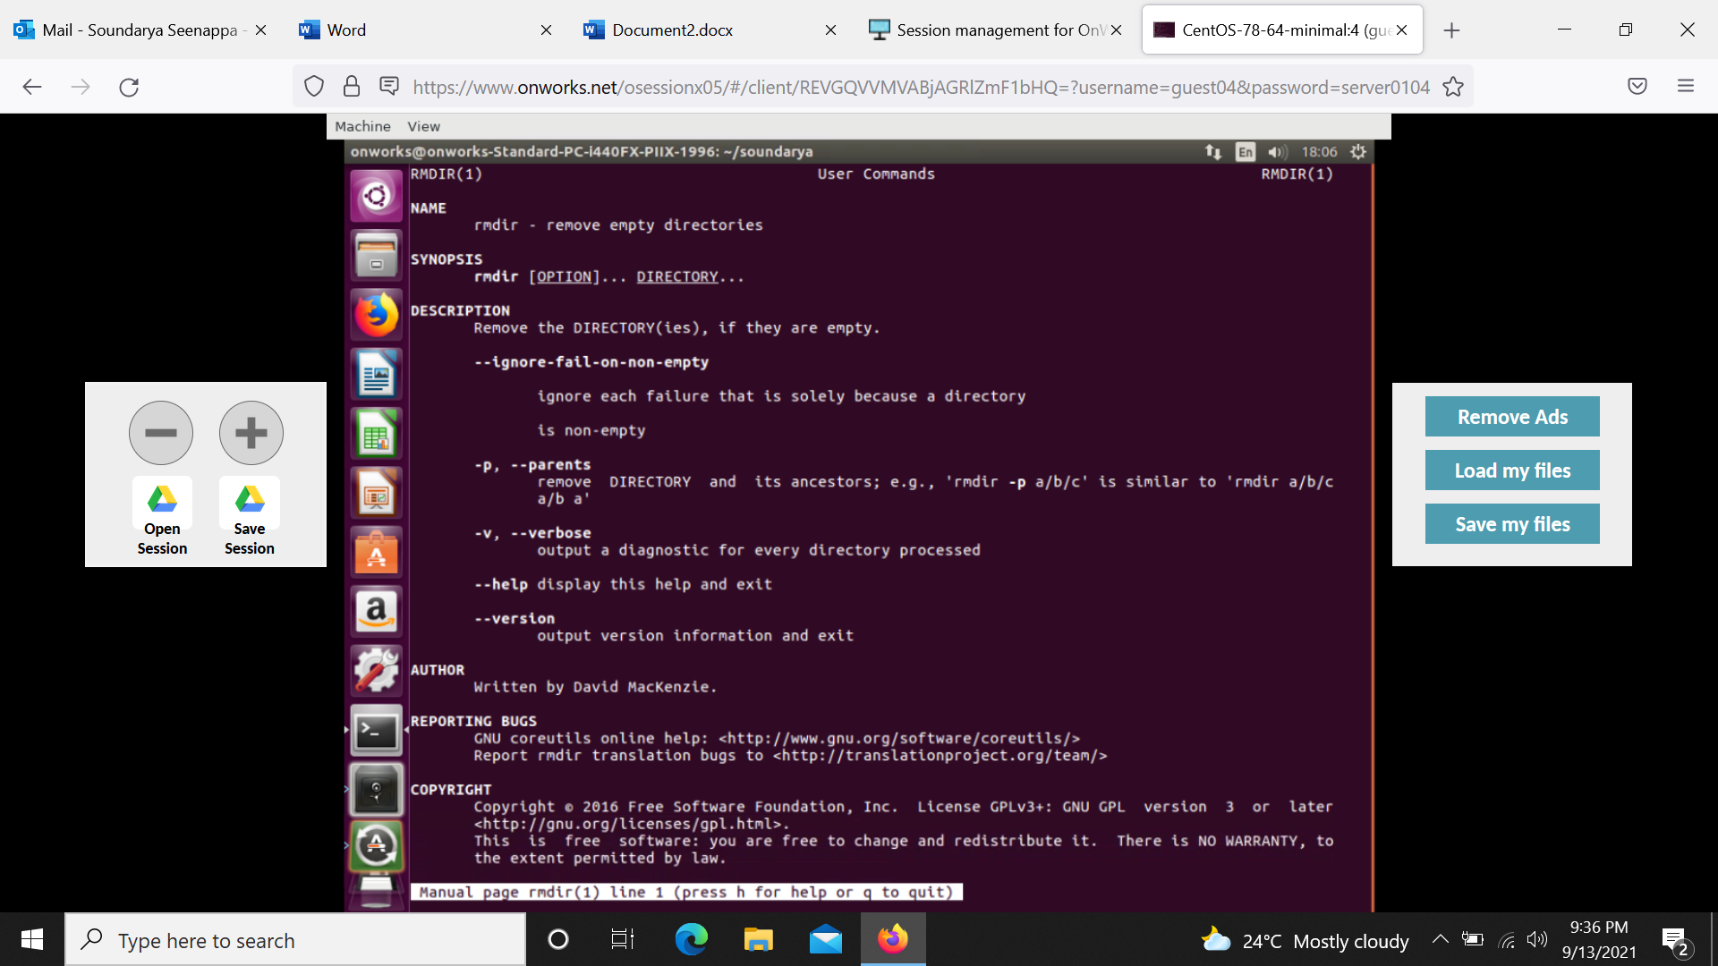

3.df(disc space usage information),df –h(size is displayed in human readable formate).

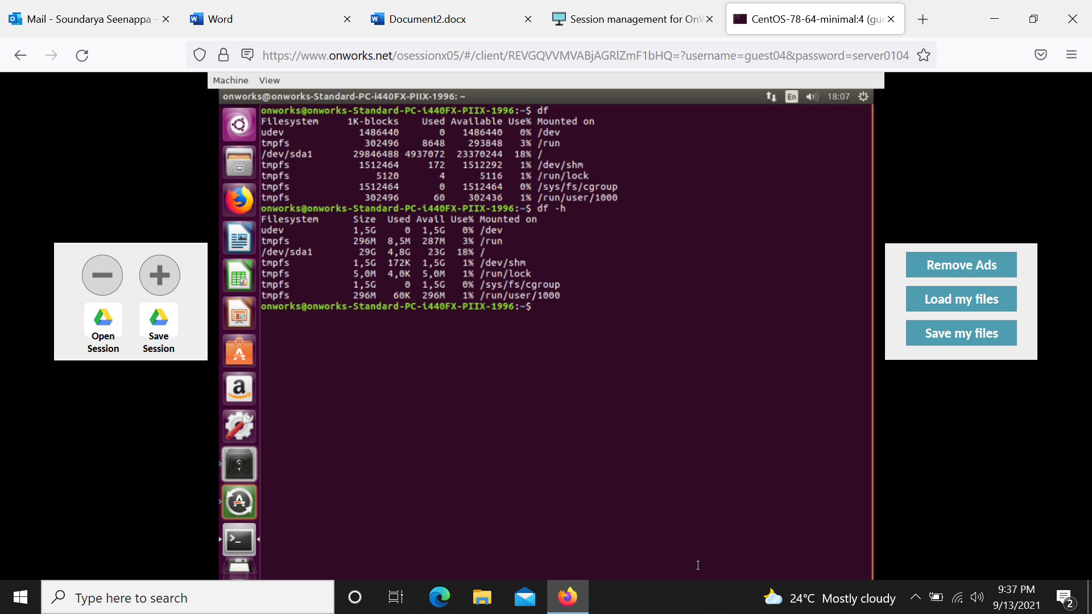

4.Manual entry(man)

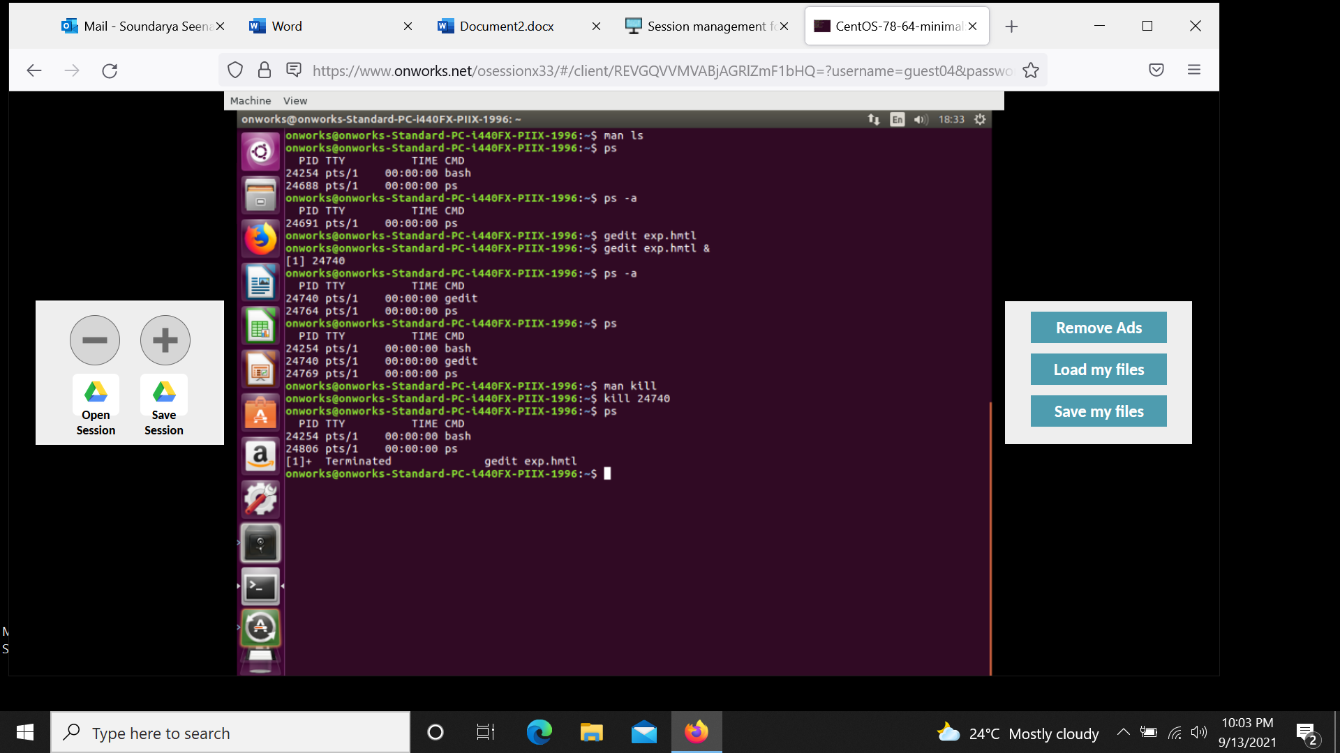

-man ls

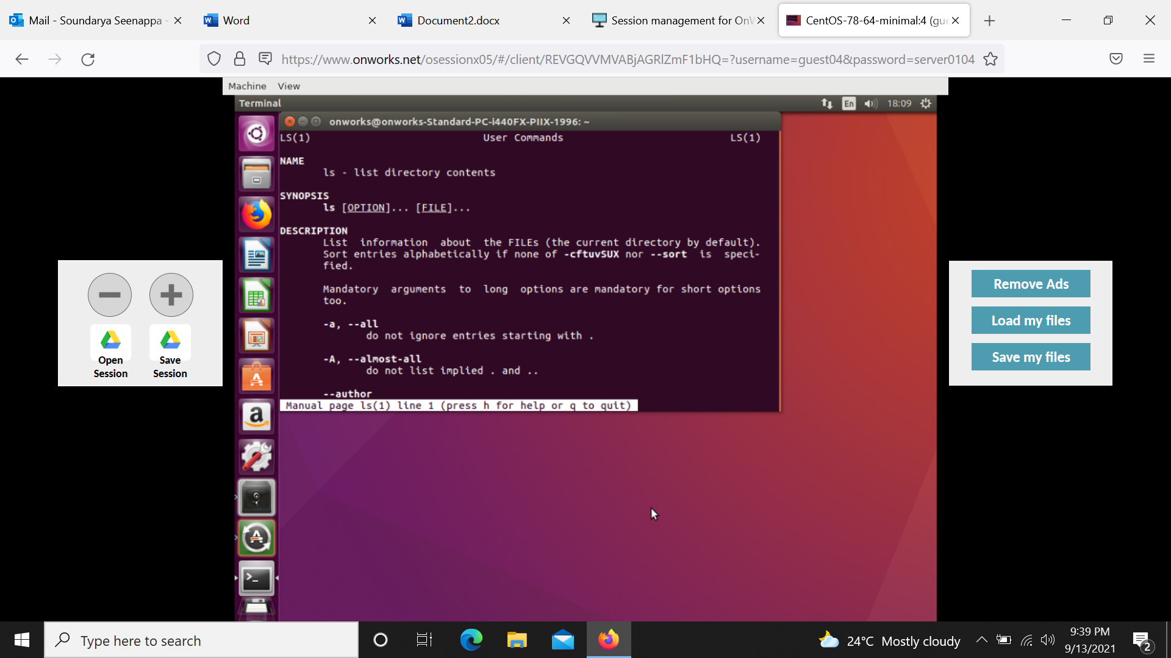

5.free,lshw

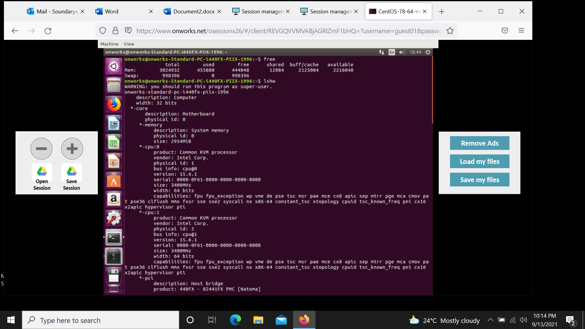

-lscpu,lsusb

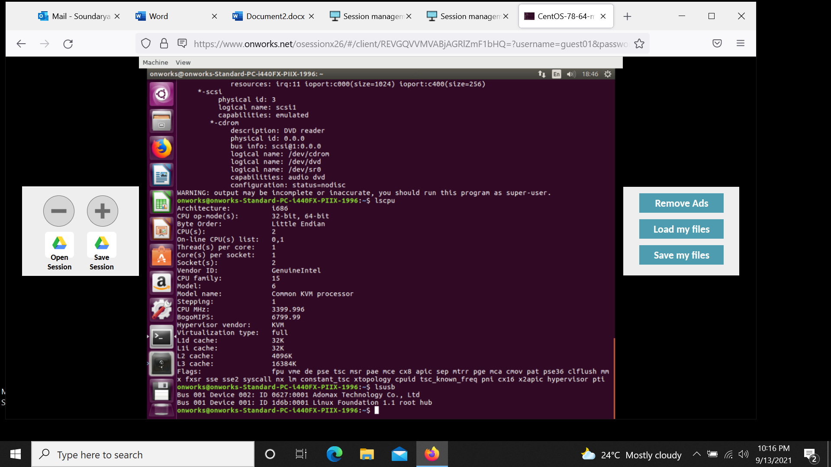

6.top

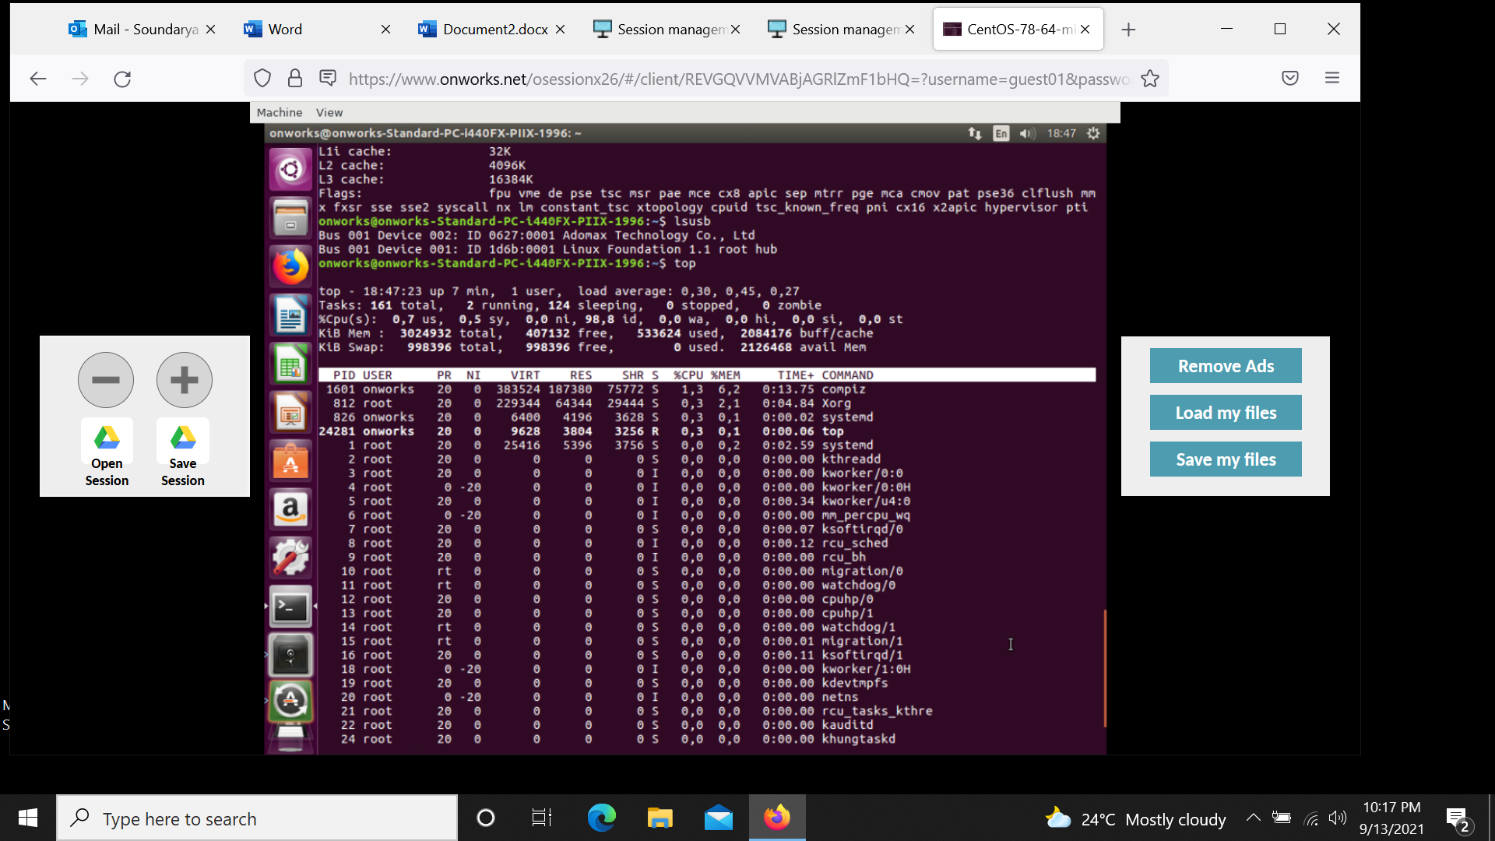

7.cat,echo

